1. Login to AWS Management Console

**How to Create AWS Account? Click –**

[**AWS - Account Creation.pdf**](https://drive.google.com/open?id=1eFMi_RyNu7N8L4Mk5DnafJafr8sVWd5d)

* Go To -  
   <https://aws.amazon.com/>
* Click on “**Sign In to the Console**” button.

**OR**

Hover the mouse pointer to “**My Account**” drop down menu and click on “**AWS Management Console**”

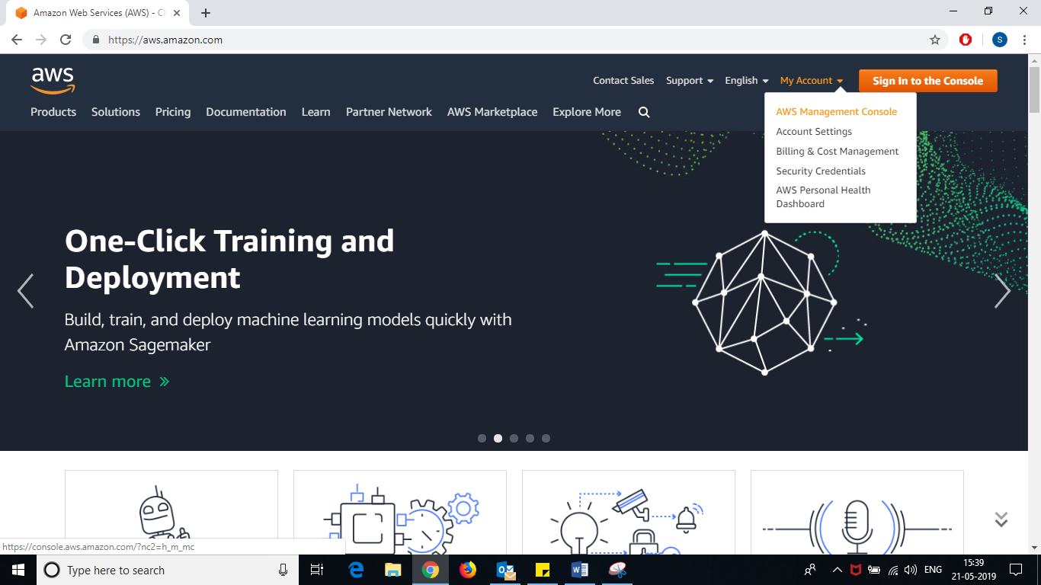

* Enter **Email Id**
* Click on “Next” button

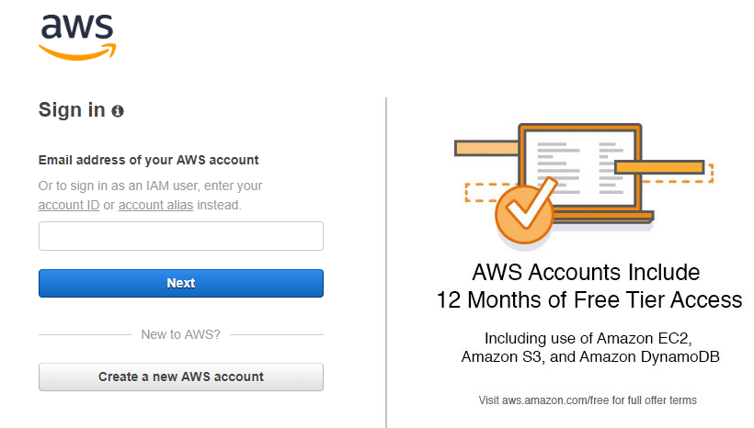

Enter your **email id** used to create AWS account.

* Enter your password
* Click on “**Sign in**” button.

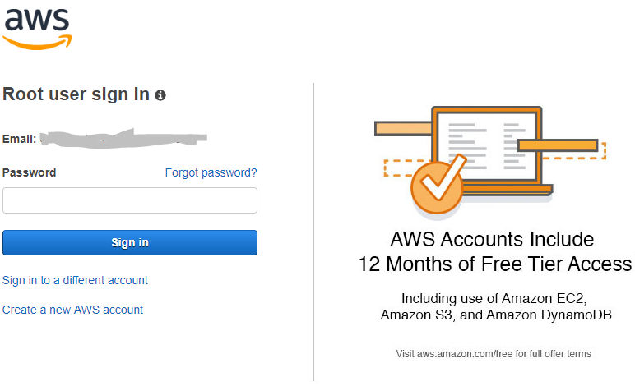

1. On the top right corner (next to your AWS Account Name), **change the region (location)** to “**Asia Pacific (Mumbai)**”

* Hover mouse to Ohio or whatever location it shows (next to your AWS Account Name).
* Select “**Asia Pacific (Mumbai)**” from the drop down list.

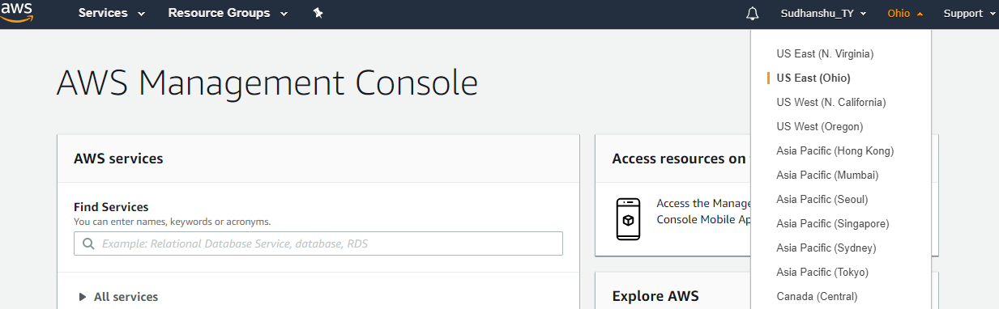

1. Expand “**All services**” 🡪 under ‘***Database***’ select “**RDS**” –

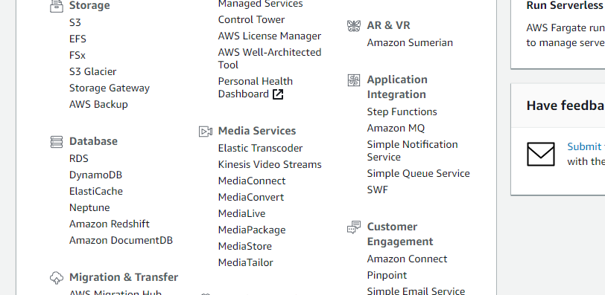

1. Click on “**Create Database**” –

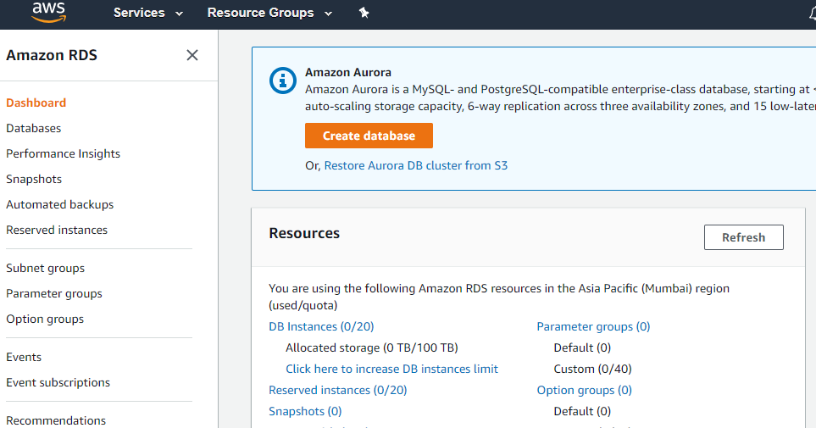

1. Scroll down completely and check the “***free tier eligible only***” checkbox –

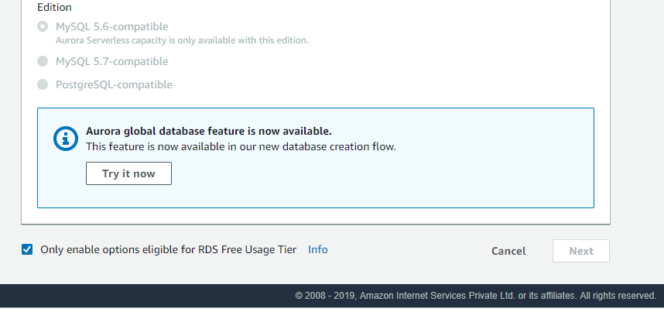

1. Scroll Up and select “**MySQL**” –

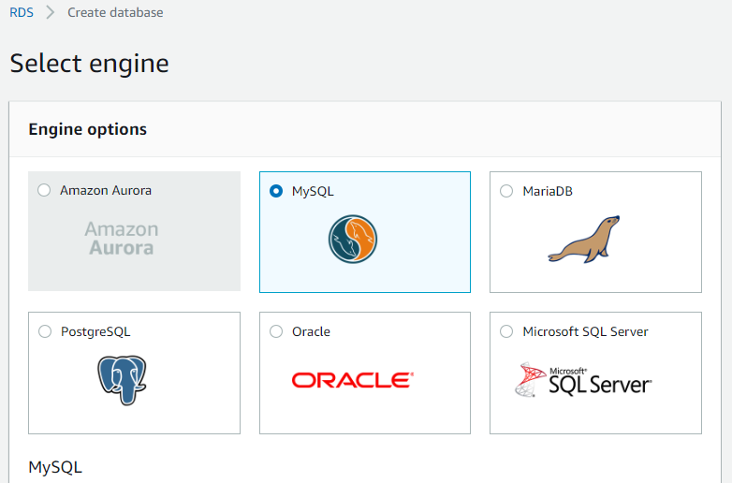

1. Scroll down and click on “**Next**” –

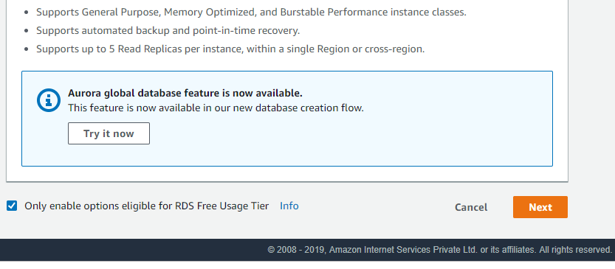

1. Scroll down and Ensure *“****Free Tier Eligible Only****”* checkbox is **checked**. If not check it –

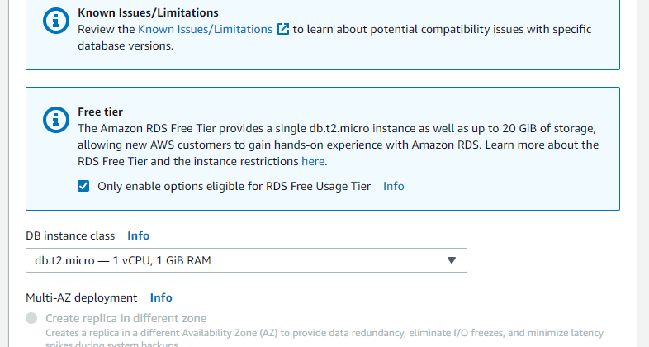

1. Scroll up and select “**DB Version**” –

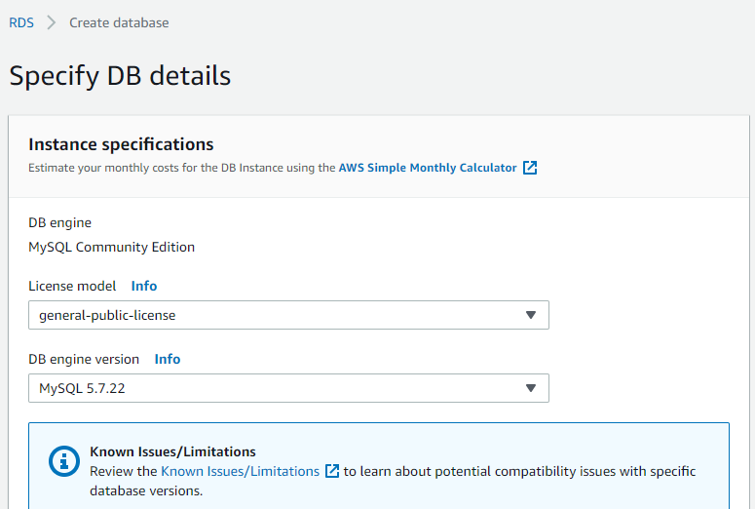

1. Enter Storage size **<=** “**20”** GiB (under RDS Free Tier usage limit)

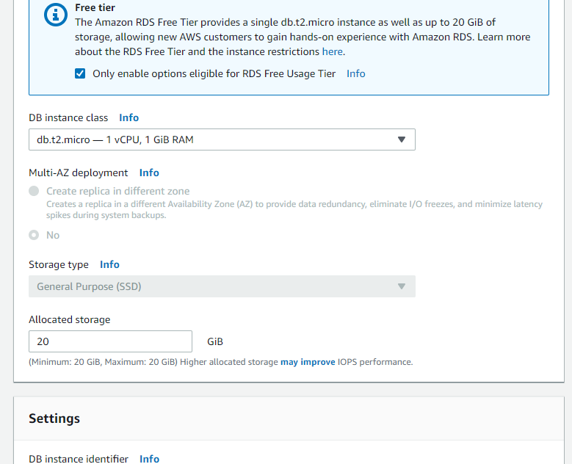

1. In the “**Settings**” section, configure settings as below –

* Db instance identifier : awsMySQLInstance
* Master username : root
* Master& confirm password: mypassword
* Click on “**Next**”

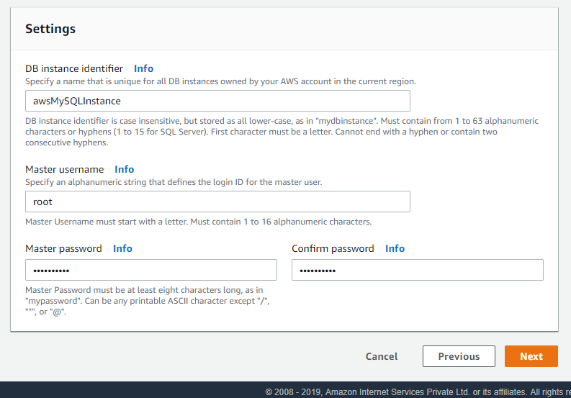

1. Against “**Public Accessibility**” select “**YES**” –

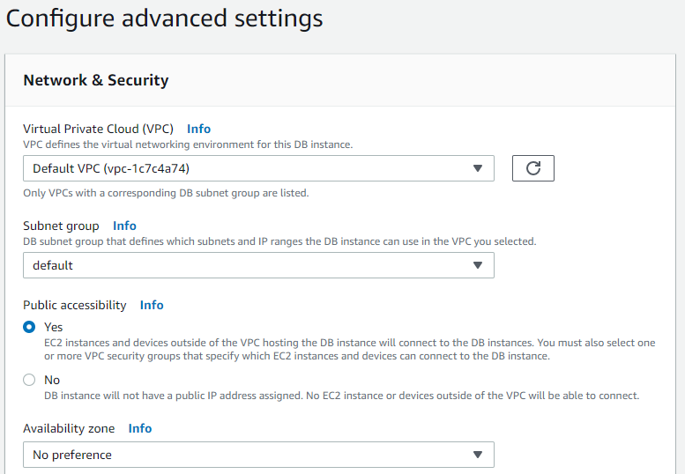

1. Select “**Create new VPC security group**” against “**VPC security group**” –

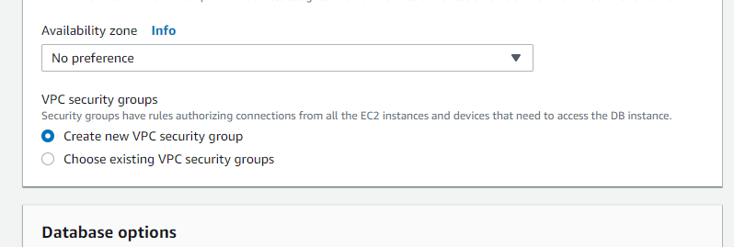

1. Scroll down, under “***Database options***” section –

* give some “**Database name”**
* Note Down the port no.
* “**Disable**” IAM DB authentication.

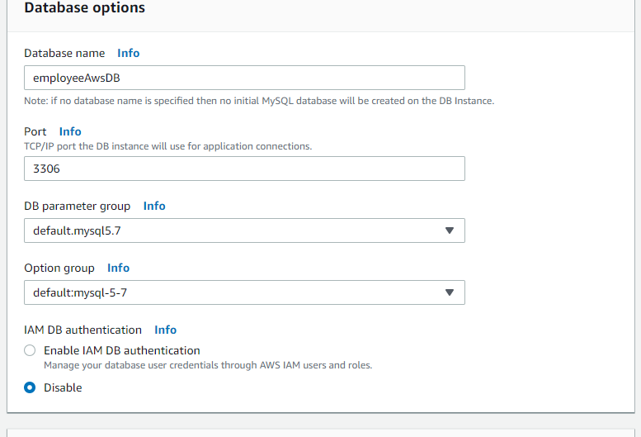

1. Scroll down, in “***Backup***” section, set “**Backup retention period**” to “**0 days**” from the dropdown. It will **disable auto-backup** of your DB Instance.

[**NOTE: -** if you want automatic backup for your DB Instance, select “**>= 1 days”** for auto-backup]

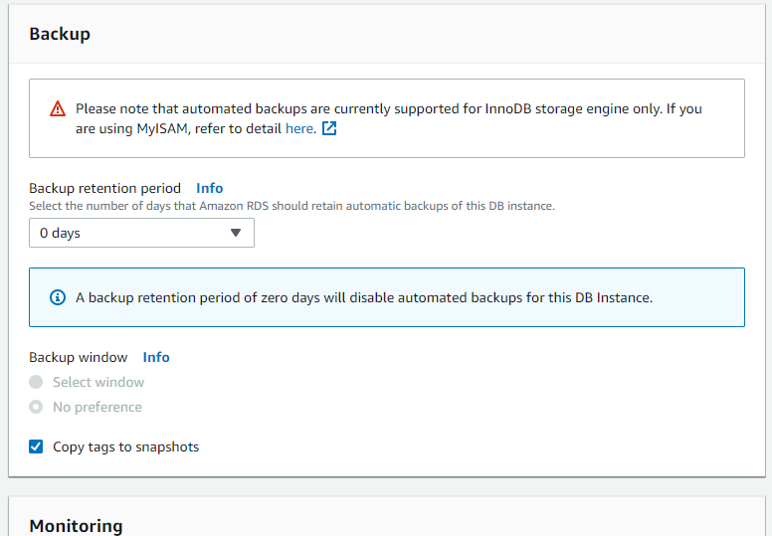

1. Scroll down completely and click on “**Create Database**” –

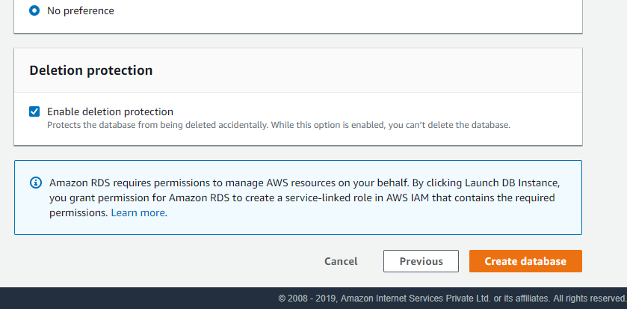

1. Click on “**View DB Instance Details**” –

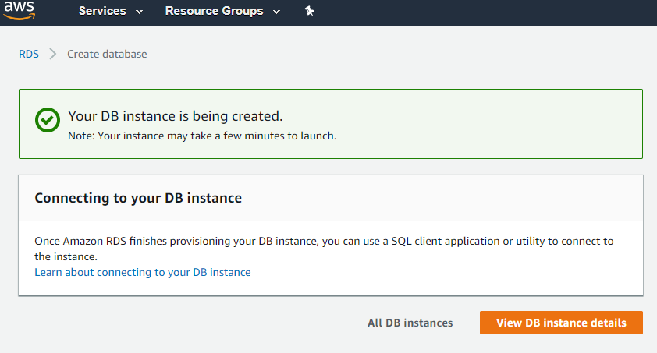

1. On the left hand side pane, click on “**Databases**” –

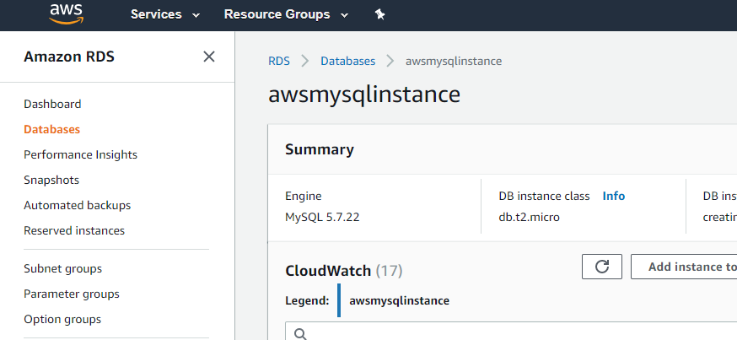

1. Check for “**Status**”.

* **Wait** until it becomes “** Available**”.

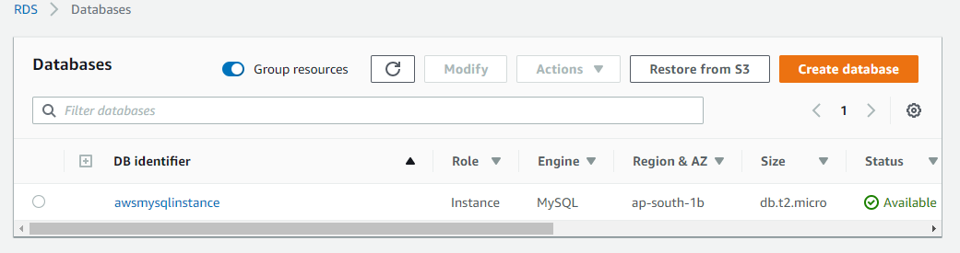

* ***“You are ready with your MySQL DB Instance”.***

1. To find out the **ENDPOINT** URL and **PORT** to connect to your MySQL Instance, click on your instance (**awsmysqlinstance**) –



1. Scroll down, under “***Connectivity & Security****”* u can find **Endpoint & Port** details to connect to your DB Instance –

